HW10 Deployment
Тестовый запуск from WSL:
sudo apt update
sudo apt upgrade -y
sudo apt install -y python3 python3-pip python3-venv python-is-python3
curl -fsSL https://deb.nodesource.com/setup_20.x | sudo -E bash -
sudo apt install -y nodejs
node -v
sudo apt install -y nginx
sudo systemctl status nginx
cd back
python3 -m venv .venv
source .venv/bin/activate
pip install --upgrade pip
pip install -r requirements.txt
uvicorn app.main:app --host 0.0.0.0 --port 8000
браузер: http://localhost:8000/redoc

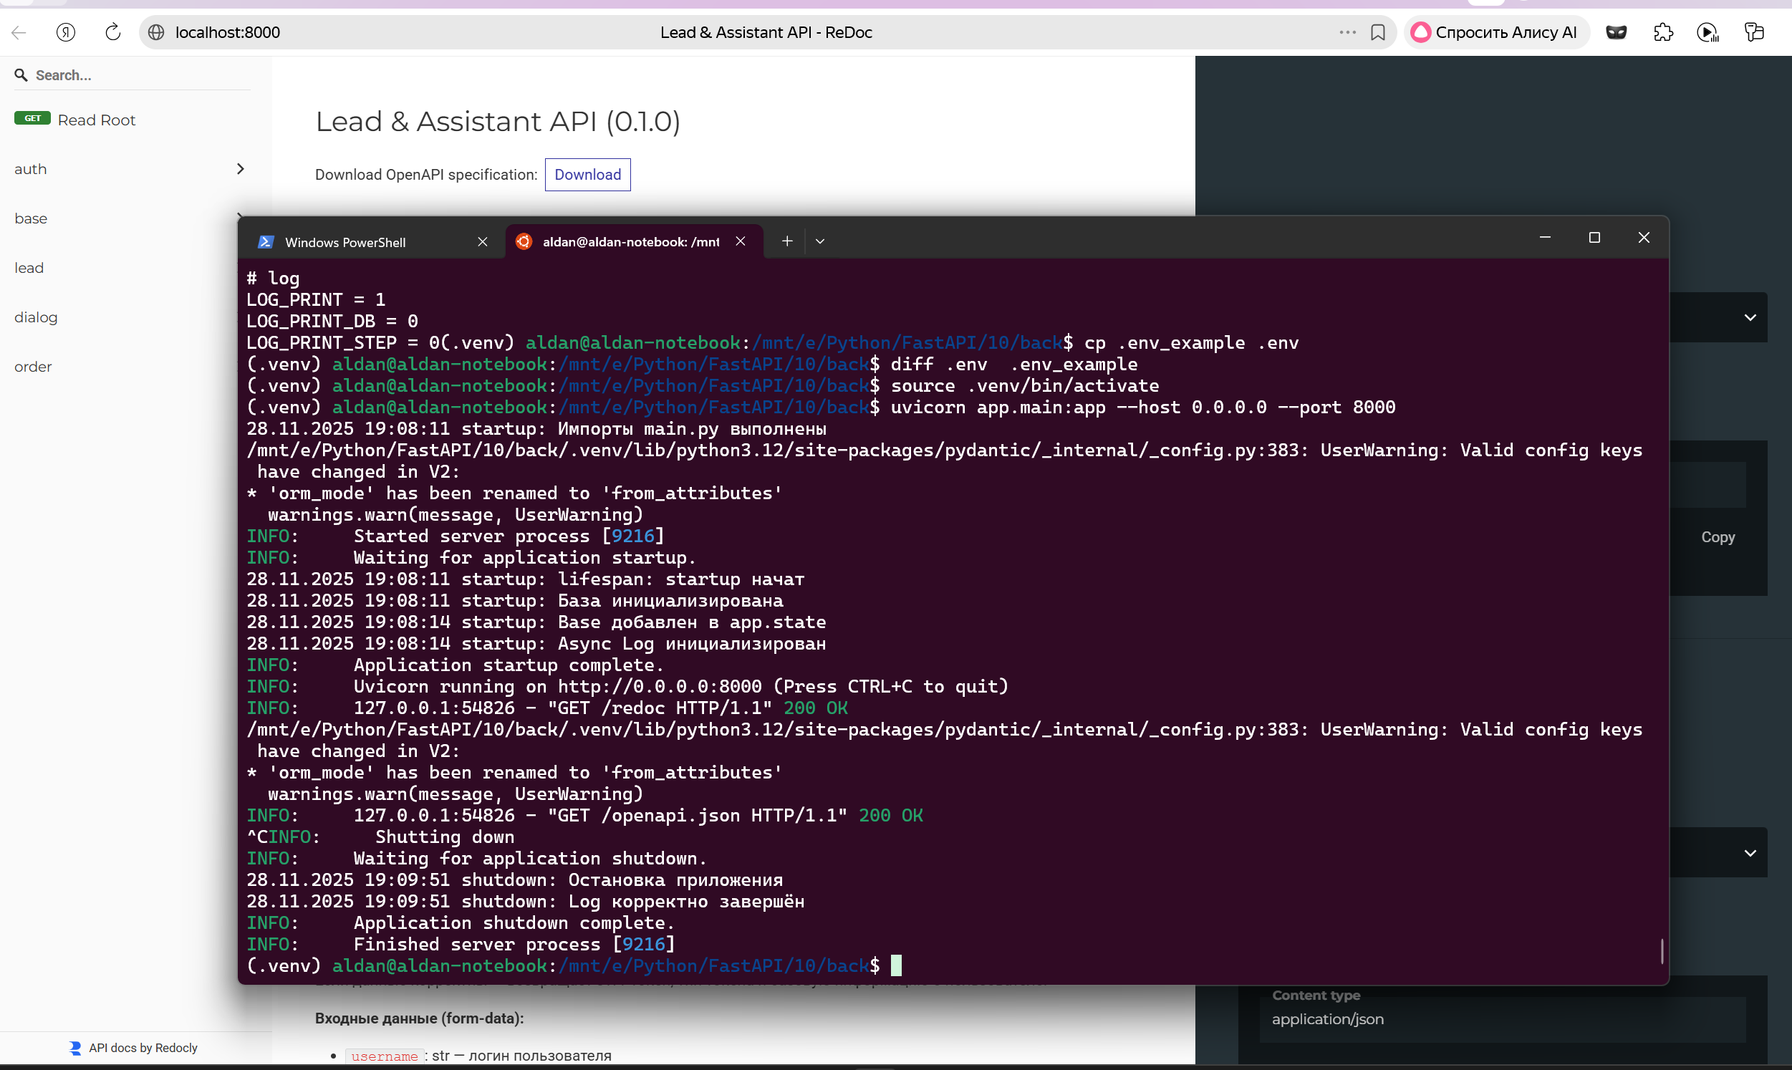

Настройка systemd сервиса
sudo cp deploy/back.service /etc/systemd/system/
sudo mkdir -p /var/www/project
sudo cp -r back /var/www/project/
sudo chown -R www-data:www-data /var/www/project
sudo systemctl daemon-reload
sudo systemctl start back.service
sudo systemctl enable back.service
sudo systemctl status back.service
Logs:
sudo journalctl -u back.service -f
Restart service:
sudo systemctl restart back.service
Frontend:
cd front
npm install
vi .env VITE_API_URL=http://localhost:8000/
npm run build
sudo cp -r front /var/www/project/
sudo chown -R www-data:www-data /var/www/project/front

Nginx:
sudo cp deploy/back.conf /etc/nginx/sites-available/
sudo cp deploy/front.conf /etc/nginx/sites-available/
sudo ln -s /etc/nginx/sites-available/back.conf /etc/nginx/sites-enabled/
sudo ln -s /etc/nginx/sites-available/front.conf /etc/nginx/sites-enabled/
sudo nginx -t # test config
sudo systemctl restart nginx

Frontend: http://localhost/
Backend API: http://localhost/redoc
Docs:
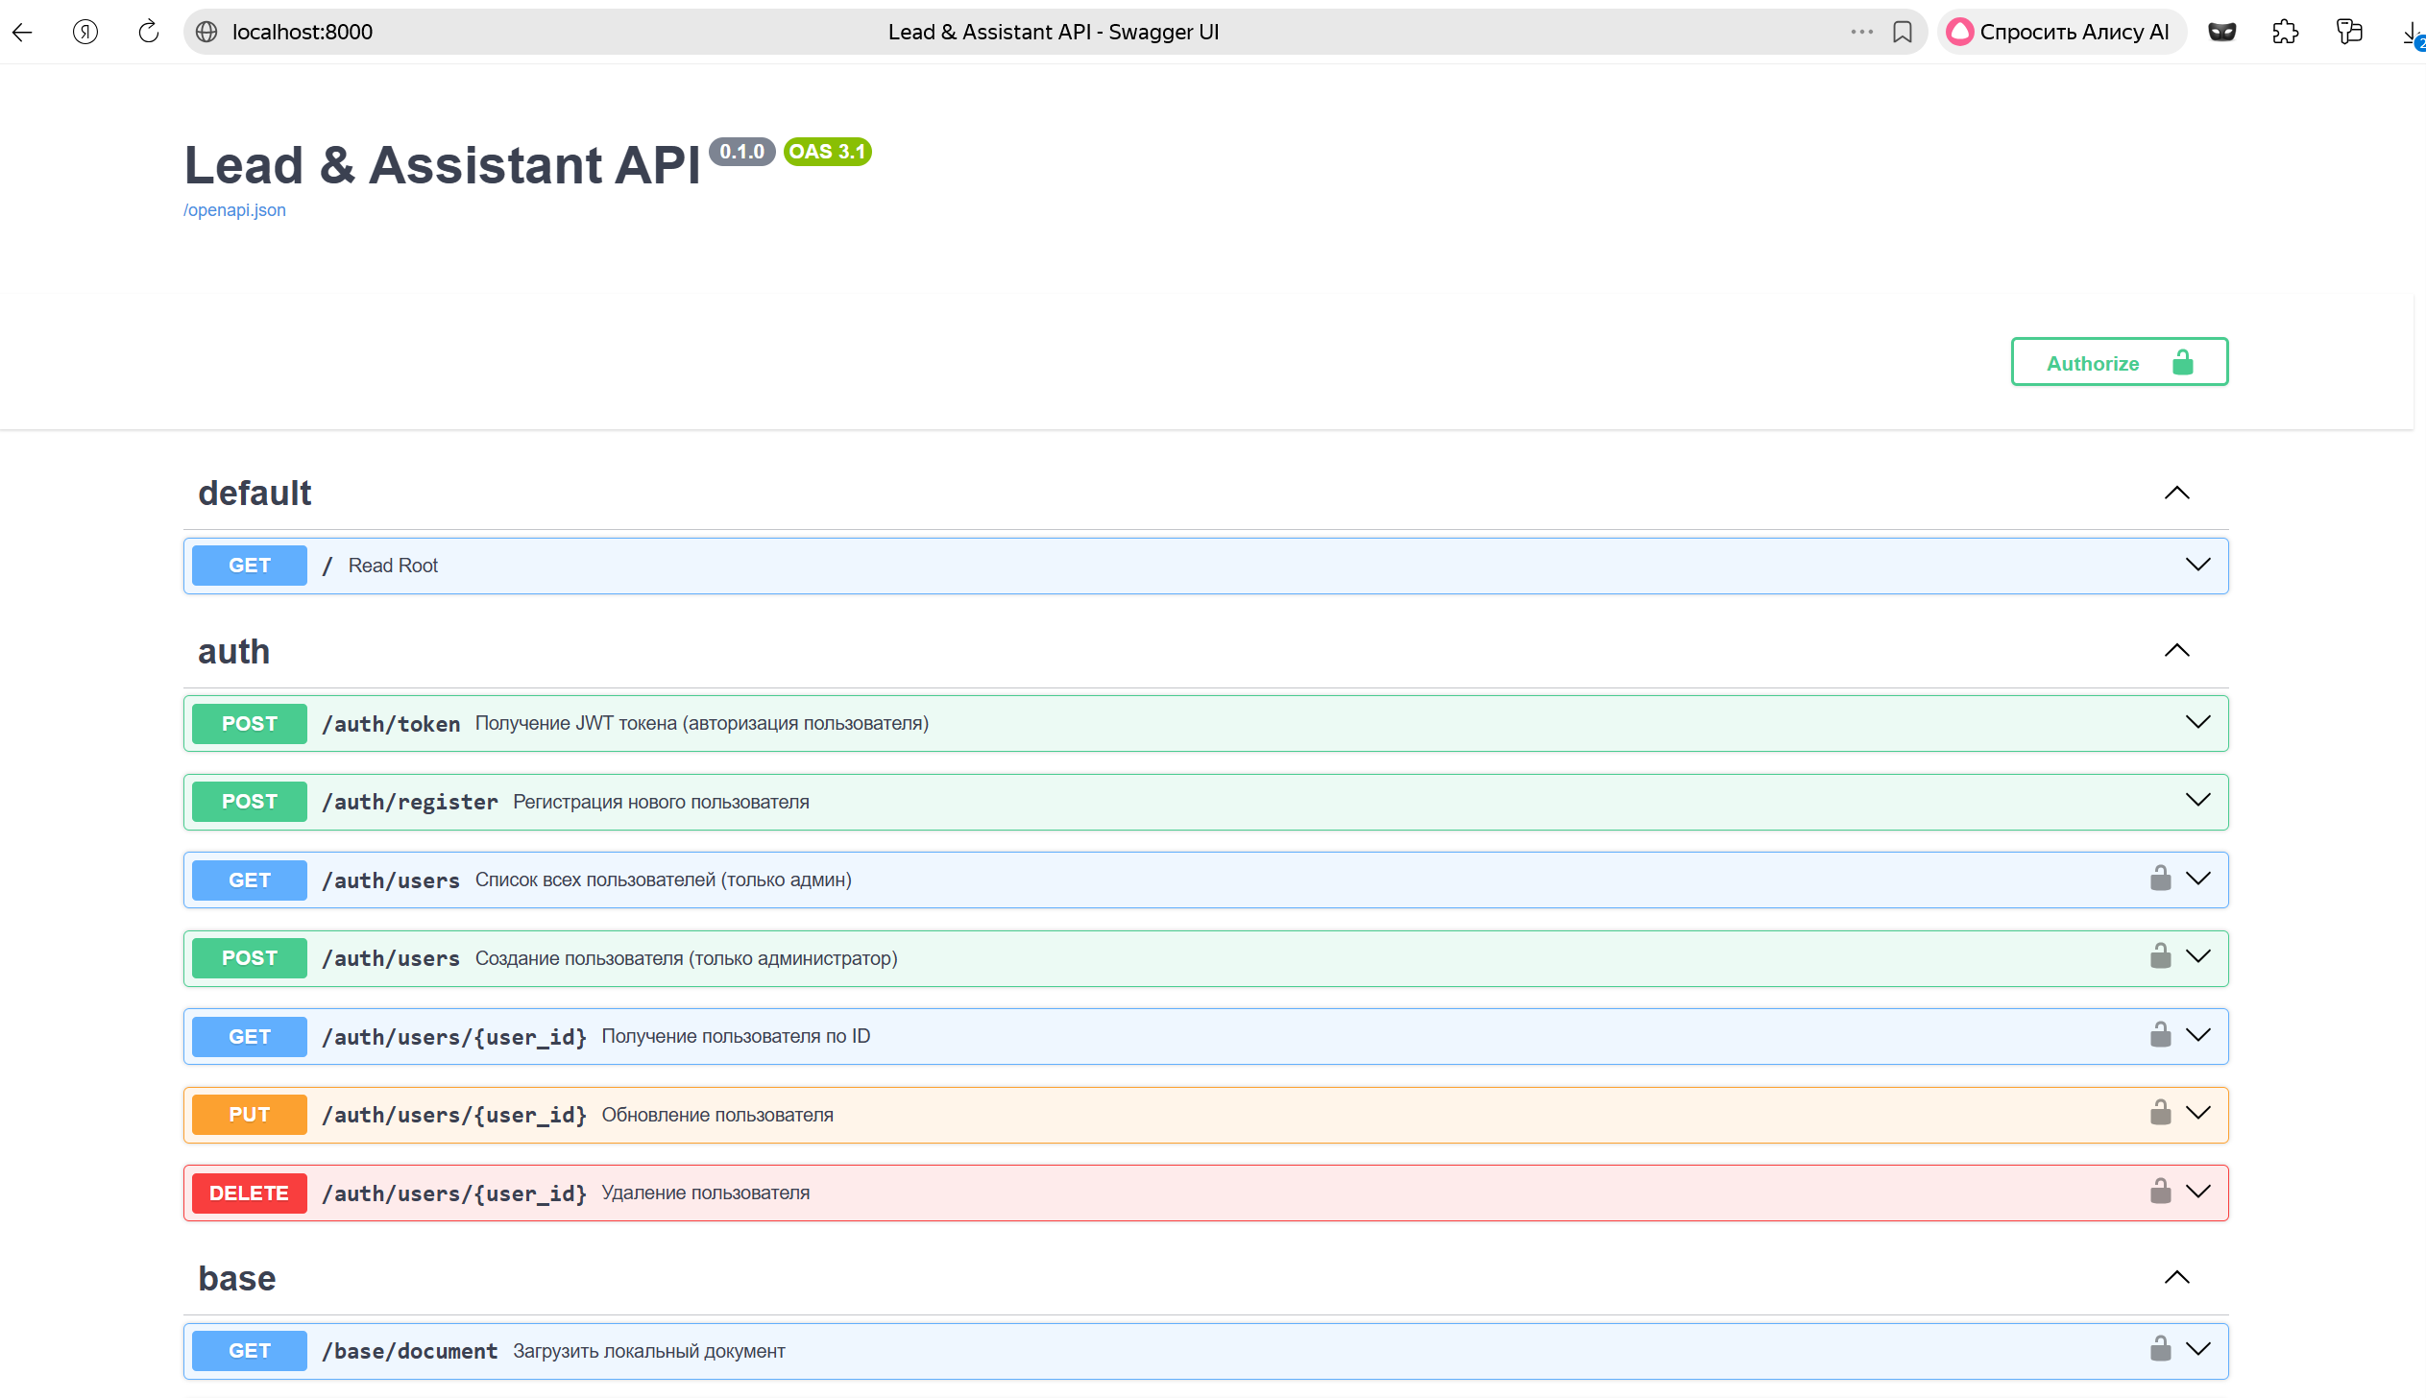
Register new user eugene, backend api works:
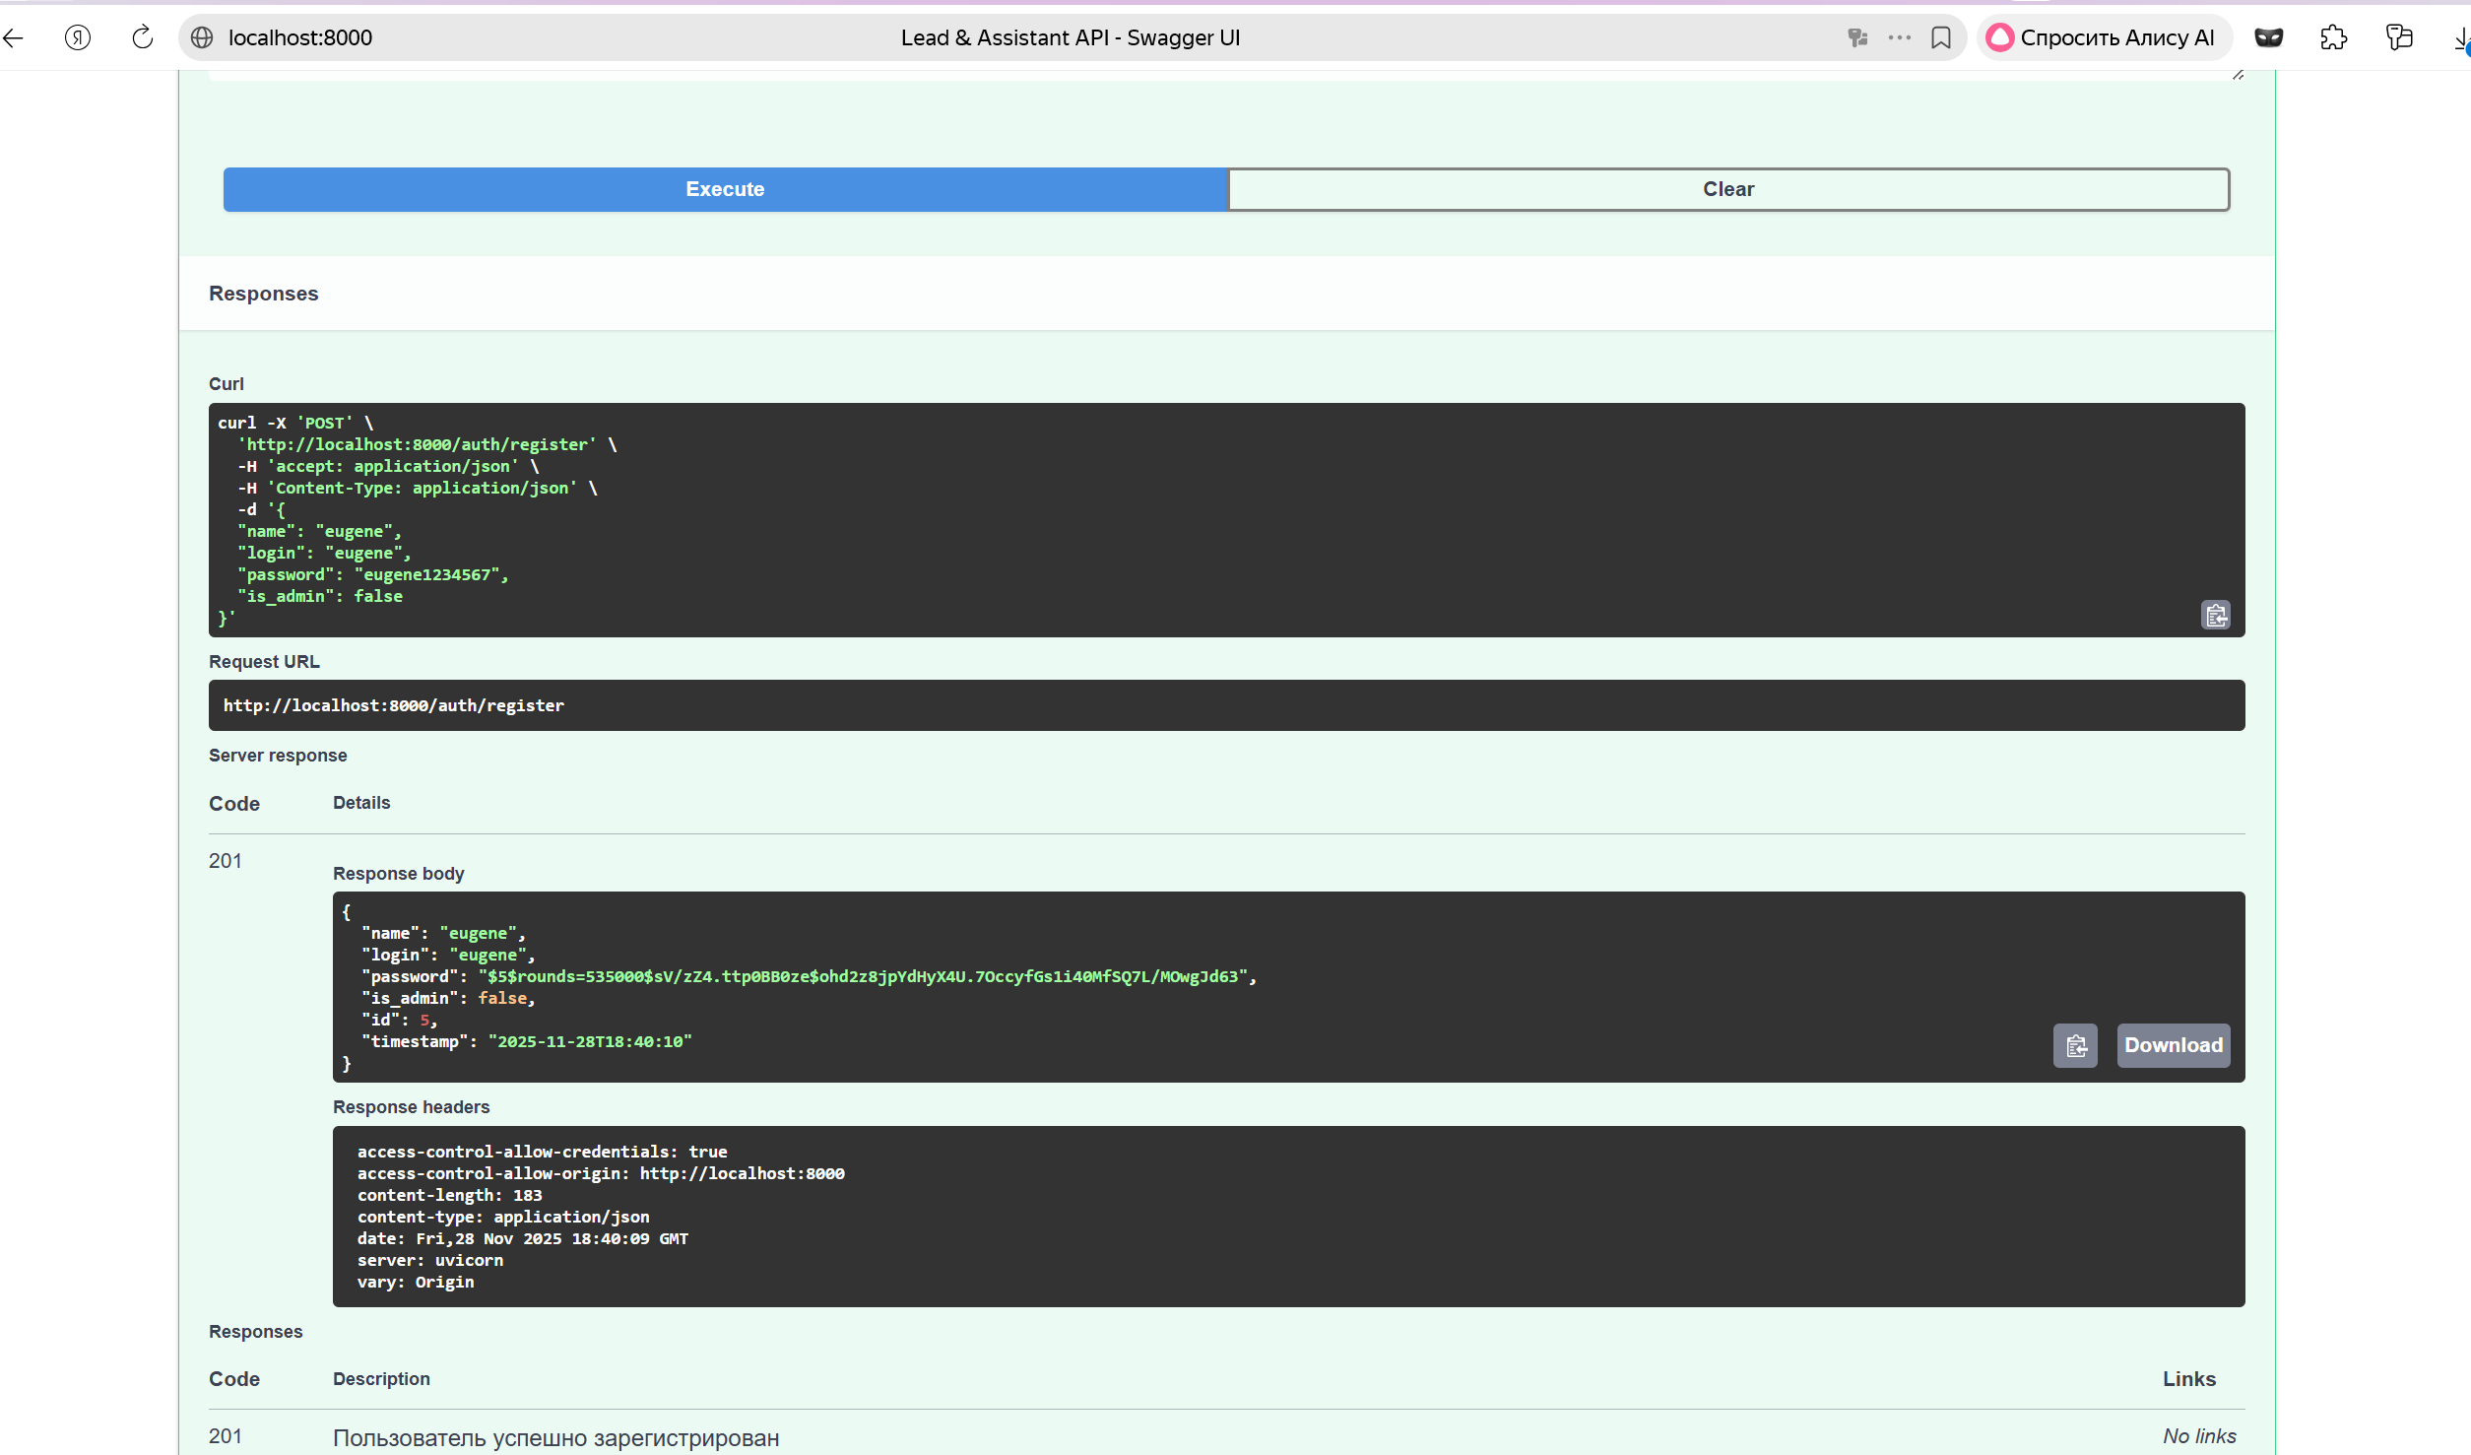

Frontend login page:
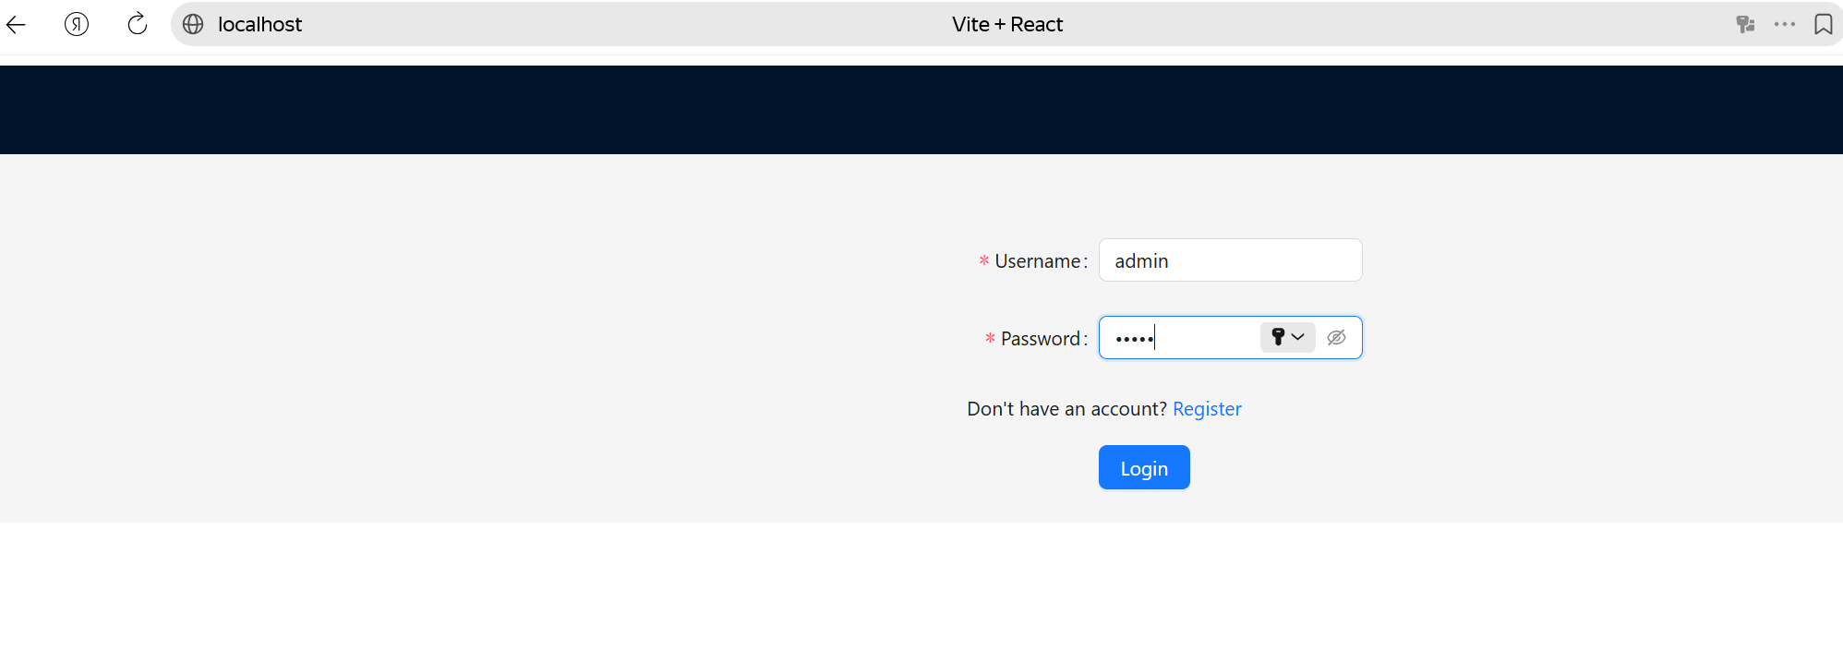
Authorized:
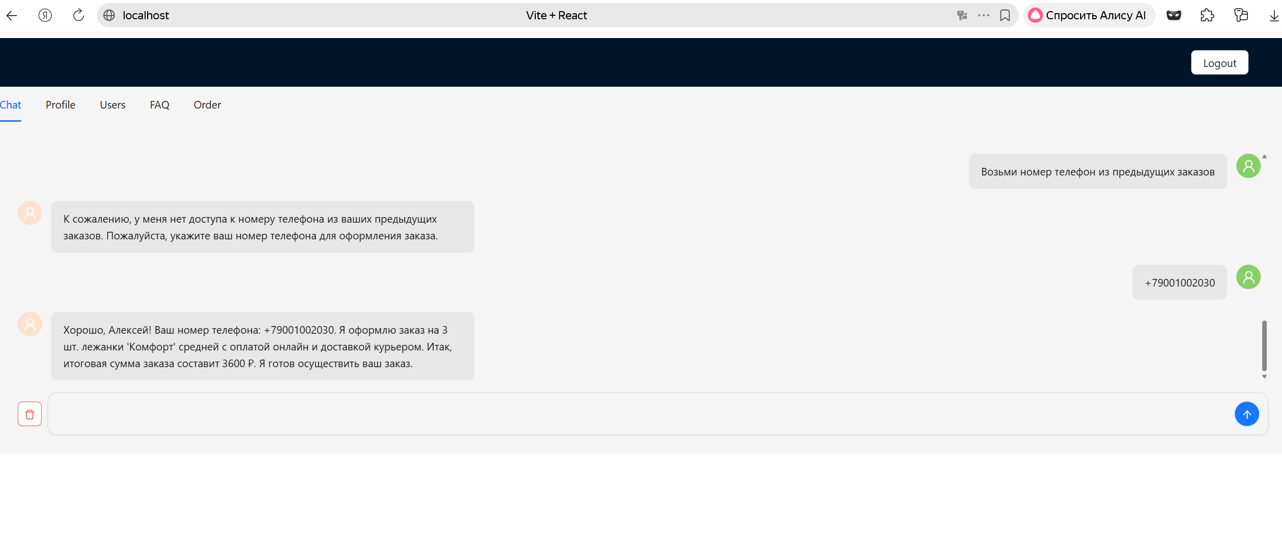
FAQ:
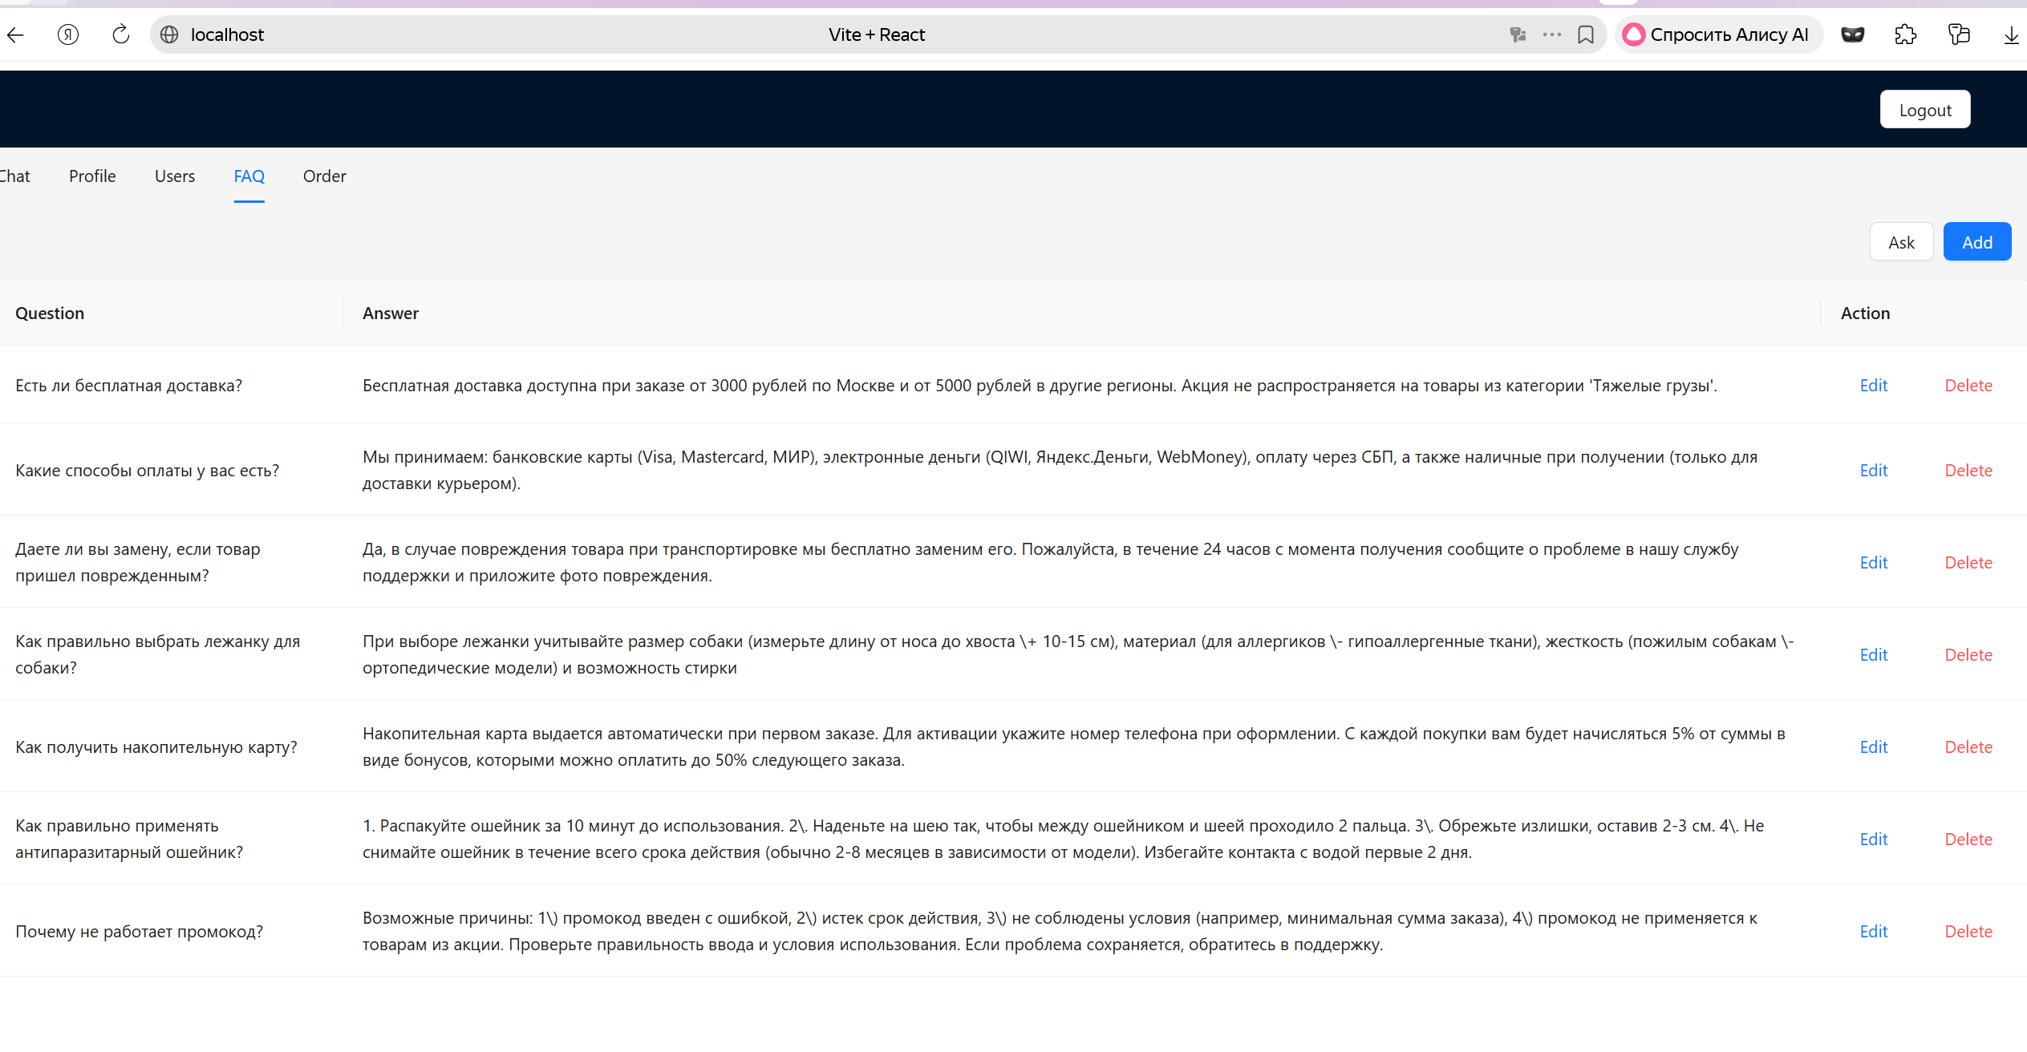
Users:
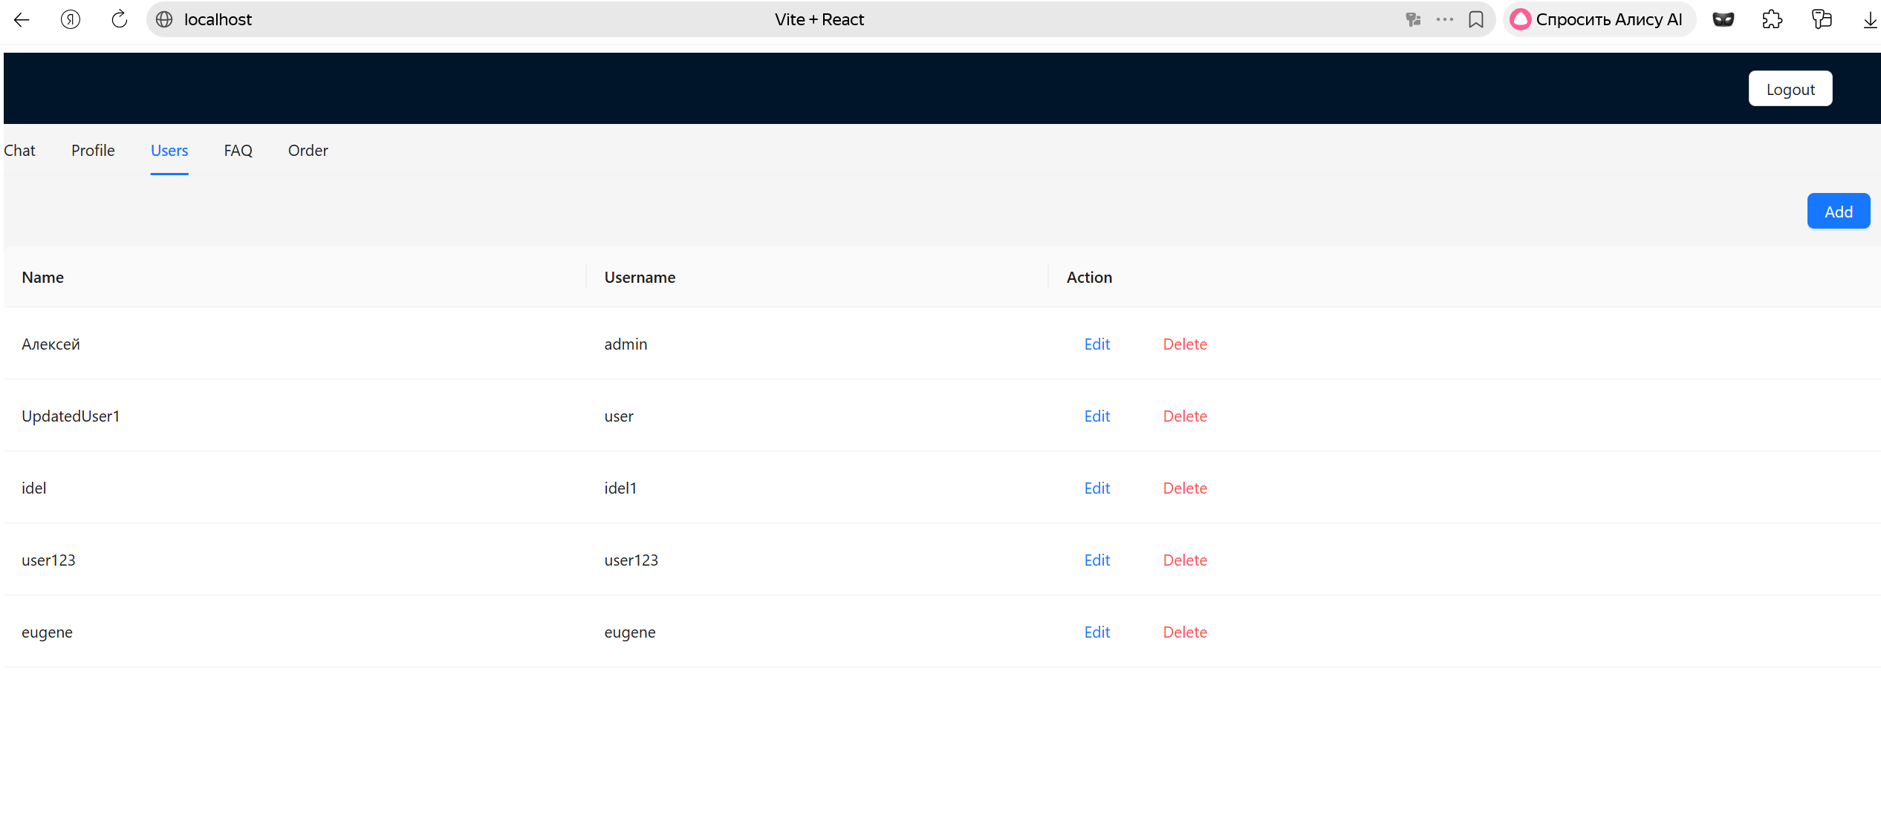
Both, frontend and backend deployed and working.
Processes for user www-data, front and back:
